# Wireless Protocols for Internet of Things

# **Introduction**

If you are planning to do an IoT project, you need to take decisions on sensors or actuators to use, hardware for edge device(node), and hardware for Gateway (Gateway connects your node to the internet). For communication, decisions should be made on wireless protocols (Node to Gateway), Communication Channels (gateway to the cloud), Network Protocols, and IoT cloud platform to be used.

In this article, I will be briefly discussing wireless communication protocols that are widely used in the IoT space. For each protocol, a brief description of the protocol followed by its Pros & Cons, technical features, application areas and website links for further exploration are given.

**Wi-Fi**

Wi-Fi is a technology developed for electronic devices to connect to a wireless Local Area Network (WLAN). Wi-Fi uses the 2.4 gigahertz (12 cm) UHF and five gigahertz (6 cm) SHF ISM radio bands. The Wi-Fi Alliance defines Wi-Fi based on the IEEE 802.11 standards. It has various encryption technologies WEP, WPA, WPA2, etc., and is password protected. However, it can be used as open Wi-Fi without any password, which allows any device within its range to access the resources of the WLAN network.

Wi-Fi technology has been used widely in the IoT ecosystem as it serves in terms of utilizing the current infrastructure for the new Internet of thing technology.

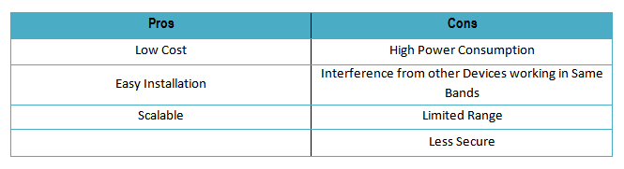

**Standard:** Wi-Fi Alliance  
**Frequency:** 2.4 GHz, 5.8GHz  
**Range:** 10–100 m  
**Data Rates:** 11–105 Mbps  
**Application Focus:**  
1. Residential & Commercial IoT router  
2. Smart traffic management  
3. Office automation

### **Bluetooth Low Energy(BLE)**



Bluetooth low energy (Bluetooth LE, BLE, and Bluetooth Smart) is a wireless personal area network technology similar range to Bluetooth. BLE is designed to work with low power consumption and is inexpensive. Like Bluetooth, BLE also has specification managed by the Bluetooth SIG.

BLE is designed by the Bluetooth SIG for low-powered devices that use less data. BLE goes to sleep when not in use and wakes up when data transfer happens. This makes it ideal for IoT device, which runs on battery and consumes low power.  
The BLE modules available in the market implements a mechanism called “Dual Mode” that will make the device work with Classic Bluetooth as well as a BLE device.

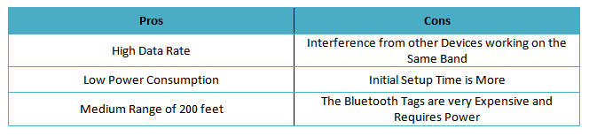

**Standard:** Bluetooth SIG  
**Frequency:** 2.4 GHz  
**Range:** 200ft  
**Data Rates:** 25Mbps  
**Application Focus:**  
1. Mobile phones  
2. Smart homes  
3. Wearable  
4. Automotive  
5. Healthcare  
6. Bluetooth payment  
7. Network availability  
8. Heart rate monitor  
9. Sports & fitness, etc.

### **ZigBee**



ZigBee is an IEEE 802.15.4 standard-based protocol for personal area network with short range, low power, and low data rate wireless data transfer.  
ZigBee is simpler and less expensive than other wireless personal area networks; ZigBee has some advantages over other wireless protocol such as low-power operation, high security, robustness and high scalability for wireless control and sensor networks IoT applications. ZigBee devices can transmit data over long distances by a mesh network passing data through intermediate neighbor devices to reach more distant. Zigbee IoT Applications include wireless ZigBee Smart Energy, Home Automation, and light switches**.**

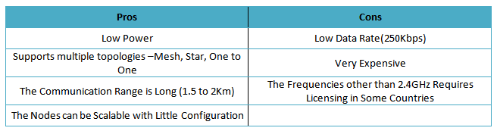

**Standard:** IEEE 802.15.4  
**Frequency:** 868/915 MHz — 2.4 GHz  
**Range:** 10–300m  
**Data Rates:** 250 Kbps  
**Application Focus:**  
1. Monitoring & Control  
2. Commercial & Industrial  
3. Home and Building Automation  
4. Medical Data Collectio  
5. Wireless Sensor Networks

### **Z-Wave**



Z-Wave is a wireless technology that lets smart devices talk to one another. The Z-Wave protocol is primarily designed for home automation. Z-wave is optimized for reliable and low-latency communication of small data packets with data rates up to 100kbit(s) and operates in the sub-1GHz band. Z-wave is simple compared to other protocol that makes it easy and faster for development.  
Z-wave has full mesh networking capabilities without the need of a coordinator node and is very scalable, enabling control of up to 232 devices

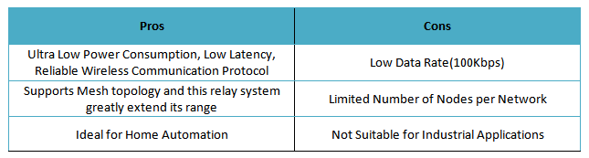

**Standard:** Z-wave  
**Frequency:** 900 MHz  
**Range:** 100 m  
**Data Rates:** 10–100 Kbps  
**Application Focus:**   
1. Control and automation  
2. Home Automation  
3. Simple Remote Control  
4. Gaming  
5. Medical Applications

### **6LowPAN**



6LoWPAN stands for IPv6 over Low power Wireless Personal Area Networks. 6LowPAN is a network protocol that defines header compression and encapsulation mechanisms allowing IPv6 packets to be sent and received over IEEE 802.15.4 based networks. The 6LoWPAN is specifically developed for low-power devices with limited processing capabilities, which can be able to participate in the Internet of Things. 6LoWPAN is the name of a concluded working group in the Internet area of the IETF.

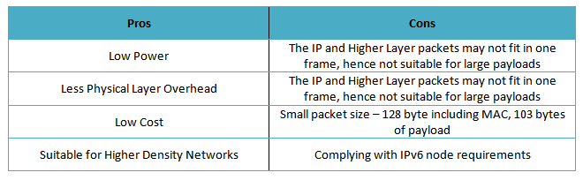

**Standard:** IEEE 802.15.4  
**Frequency:** 2.4 GHz  
**Range:** 200 m  
**Data Rates:** 200 Kbps  
**Application Focus:**   
1. 6LowPan Smart Meters  
2. Smart Lighting  
3. Thermostats  
4. Smart Grid  
5. Wireless Sensor Networks  
6. Industrial Automation  
7. Advanced Traffic Management System

### **RFID**

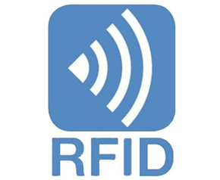

Radio-frequency identification (RFID) uses electromagnetic fields. RFID is not new since it has been used almost in every industry to identify and track tags attached to objects automatically. The tags stores information electronically. There are two types of RFID tags, Active and Passive. Passive tags collect energy from RFID reader’s radio waves whereas Active tags have its power source such as a battery and can operate at hundreds of meters distance from the RFID reader. RFID technology can be used in the IoT to identify objects and link them to the Internet.

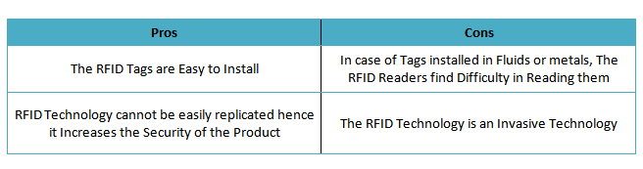

**Standard:** ISO RFID standards, EPCglobal standards  
**Frequency:** 120 KHz — 150 KHz, 13.56 MHz, and 433 MHZ  
**Range:** 10 CM to 100M  
**Data Rates:** 10–100 Kbps  
**Application Focus:**  
1. Access management  
2. Tracking of goods  
3. Tracking of persons and animals  
4. Toll collection and contactless payment  
5. Machine readable travel documents  
6. Smart dust (for massively distributed sensor networks)  
7. Electronic Lock with RFID Card System  
8. Tracking sports memorabilia to verify authenticity  
9. Airport baggage tracking logistics  
10. Timing sporting events

NFC

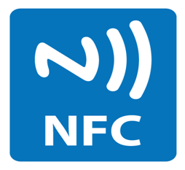

Near Field Communication (NFC) technology is used for communication between two NFC-enabled electronic devices like Smartphone. NFC communication uses electromagnetic induction between two NFC loop antennas located between near field, which effectively forms an air-core transformer. NFC operates unlicensed radio frequency ISM band of 13.56 MHz on ISO/IEC 18000–3 air interface. NFC working involves two participants, an initiator, and a target; the active initiator generates an RF field that can power a target that is passive (“NFC tag”). NFC comes in very small factors such as tags, stickers, and key fobs. NFC peer-to-peer communication is possible when provided by both devices are powered. NFC technology allows IoT device’s contactless data transfer.

**Standard:** ISO/IEC 18000–3  
**Frequency:** 13.56MHz  
**Range:** 4 cm  
**Data Rates:** 100–424kbps  
**Application Focus:**  
1. NFC contactless payment  
2. Wearable baby monitors  
3. Smart marketing posters  
4. E-Commerce  
5. Bootstrapping other Connections  
6. Identity And Access Tokens  
7. Gaming

### **Thread**



The thread is built on IEEE 802.15.4 based 6LoWPAN wireless protocol with mesh communication. The thread is a low-power, secure and scalable IP-based wireless mesh networking protocol. Thread networking provides self-healing mesh networking with over 250 nodes and support for sleepy nodes, allowing years of operation from a single battery.  
The thread was launched by thread group in 2014. Thread group Alliance today working with the companies Nest Labs, Samsung, ARM Holdings, Qualcomm, NXP Semiconductors/Freescale, Silicon Labs, Big Ass Solutions and OSRAM. The thread is IP-addressable and can have direct access to cloud and AES encryption. The thread is specifically designed for home automation setup.

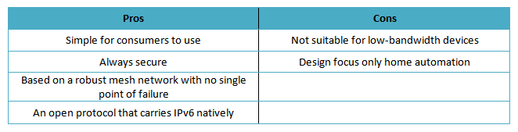

**Standard:** IEEE802.15.4 and 6LowPAN  
**Frequency:** 2.4 GHz  
**Range:** N/A  
**Data Rates:** N/A  
**Application Focus:**  
1. Connected home  
2. Home Automation  
3. Consumer utility

### **LoRaWAN**

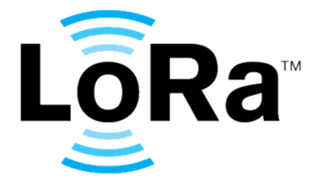

LoRaWAN is a Low Power Wide Area Network (LPWAN). LoRaWAN is a media access control (MAC) layer protocol designed for public networks in large-scale with a single operator. It is built using Semtech’s LoRa modulation as the underlying PHY. LoRaWAN used for secure mobile bi-directional communication in wireless battery operated devices. LoRaWAN is ideal where low power and long range is needed with millions and millions of devices connected.

**Standard:** LoRaWAN  
**Frequency:** Various (eg 902MHz -928MHz)  
**Range:** 2–5km (urban environment), 15km (suburban environment)  
**Data Rates:** 0.3–50 kbps  
**Application Focus:**  
1. Ideal for smart cities  
2. Environmental data monitoring

### **SIGFOX**



Another wireless wide range technology is Sigfox which comes with a range between Wi-Fi and cellular. Sigfox uses free ISM band to transmit data over the very narrow spectrum. Sigfox is designed to handle low data-transfer speeds of 10 to 1,000 bps using an Ultra Narrow Band (UNB) technology. Sigfox overcomes the problem of Wi-Fi and cellular in many applications that has short Wi-Fi range, where cellular cost is high and consumes more power.  
SIGFOX is a French company that builds wireless networks, which is founded in 2009 by Ludovic Le Moan and Christophe Fourtet. Typically, it is an internet of things device that needs to transmit continuously in small amount data. Best use cases for Sigfox are electricity meters, smart watches, and washing machines.

**Standard:** Sigfox  
**Frequency:** 900MHz  
**Range:** 30–50km (rural environments), 3–10km (urban environments)  
**Data Rates:** 10–1000bps  
**Application Focus:**  
1. Smart meters  
2. Patient monitors  
3. Security devices  
4. Street lighting  
5. Retail including point of sale, shelf updating, etc  
6. Environmental sensors